All the interfaces of the HireBuddy application were designed using a user-friendly manner. Since the HireBuddy application is commonly used by many sorts of people the appearance of the interfaces is significant and it must be more attractive and simplistic as well as it will urge a different kind of people to use this application in their daily activities.

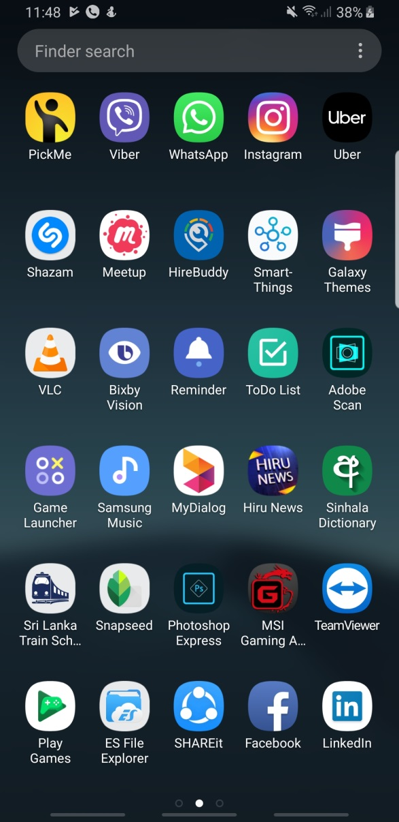The application icon is build up with the application logo and attractive color variants. When compares with the professional level applications the HireBuddy icon is also at a top level.

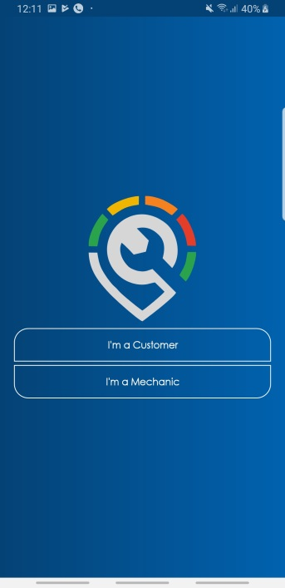When starts the application the user will be navigated to the welcome screen of the application. It consists of animating application logo and after a few seconds, the user selection screen will automatically appear.

Thereafter the user will proceed to select the login method. As to the user selection, the login activity will appear. The login activity window consists of Email and password text boxes and some user selection functions as shown in the figure.

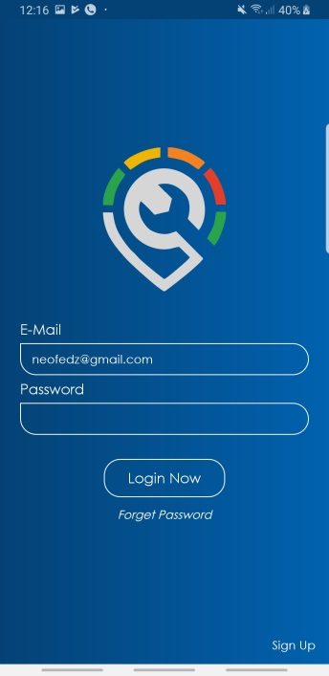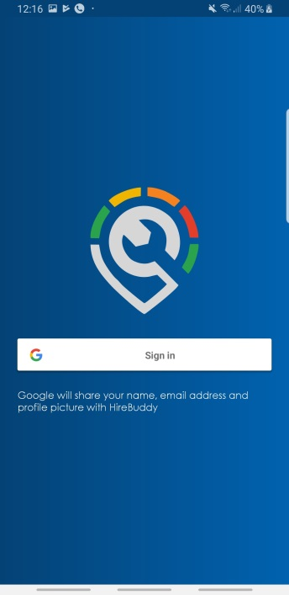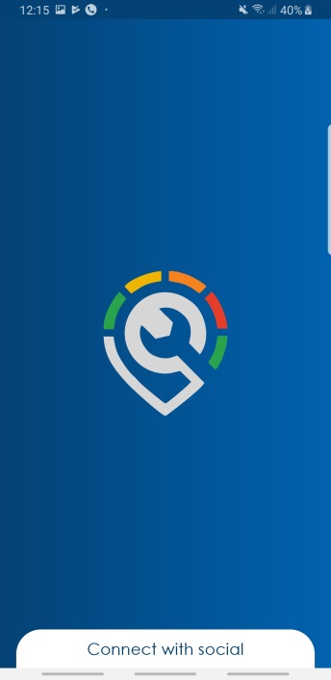

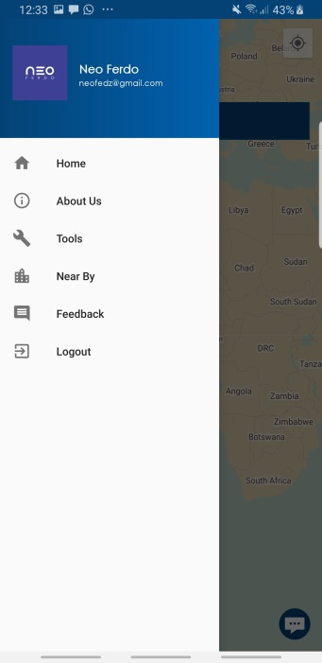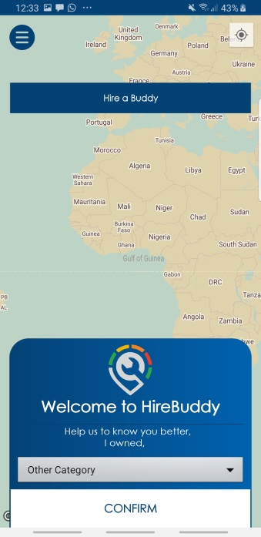After the login scenario, it will proceed to the significant interface which contains a map, navigation pane and some other objects. Once the user selects the floating button the navigation pane will appear. These components will be changed according to the user type.

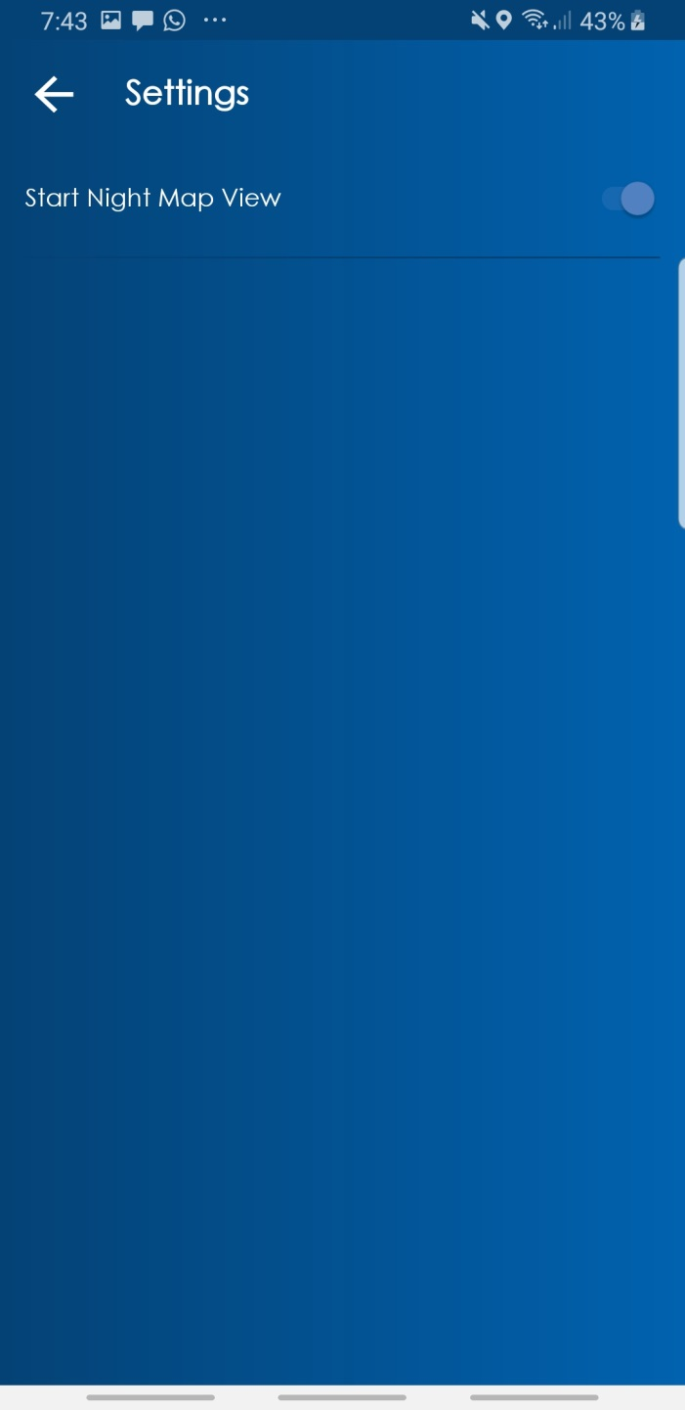The style of the map is getting change according to the system time as shown in the following figures. And the user is able to enable or disable this feature from the application options.

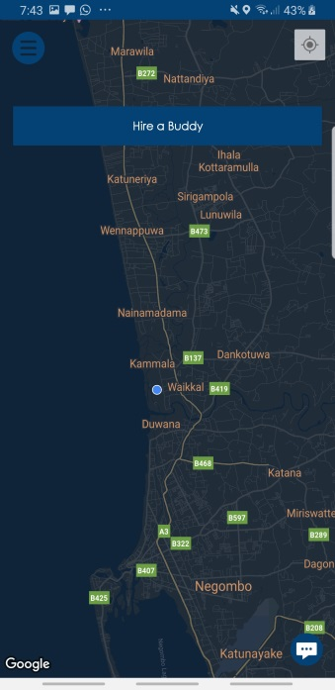

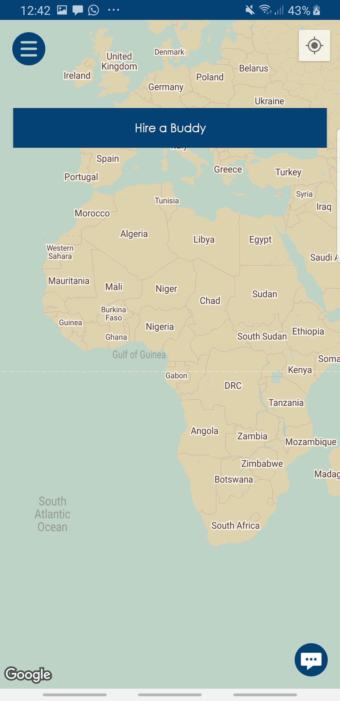

There is another interface allocated for getting user feedbacks. Since the project is following Agile Methodology it is important. Therefore the interface is designed in a simplistic manner. And it contains with

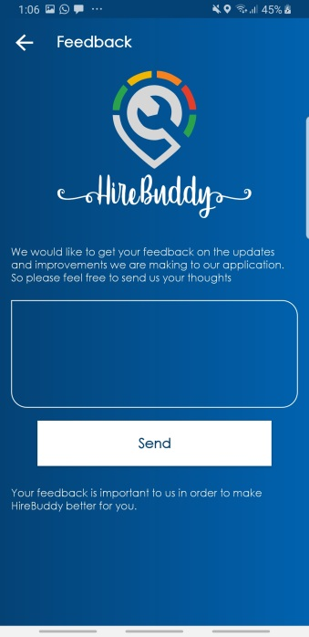

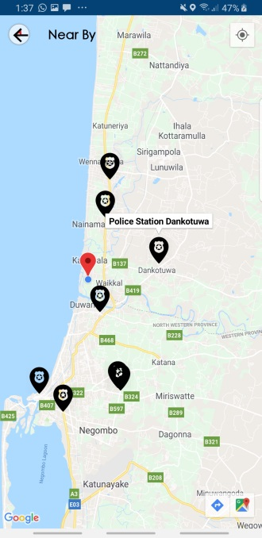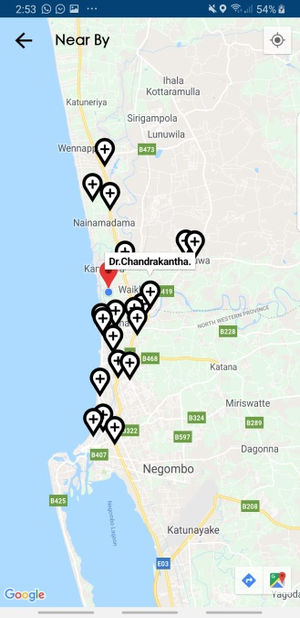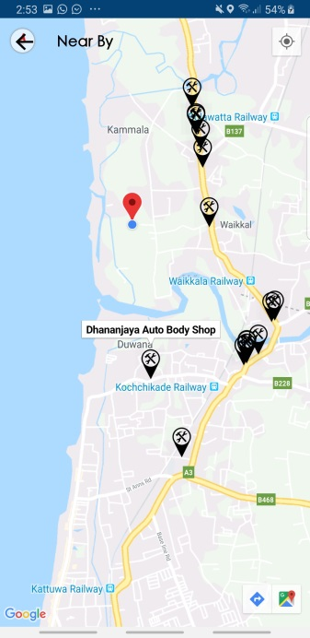When showing nearby Police stations, Car Repair stations and Hospitals it allows the user to select the place, after that as to the selection nearby places will displays. To mark the place the application is using different types of markers.

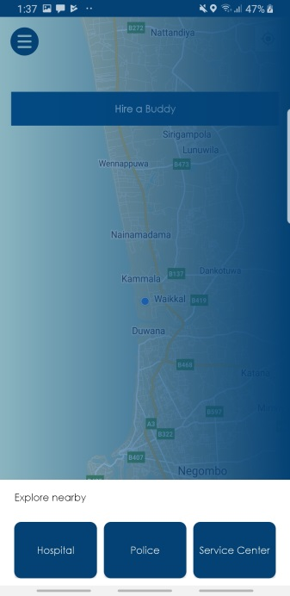

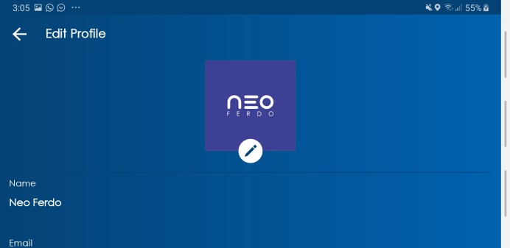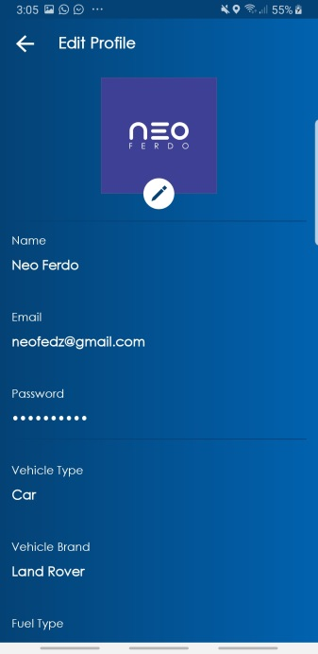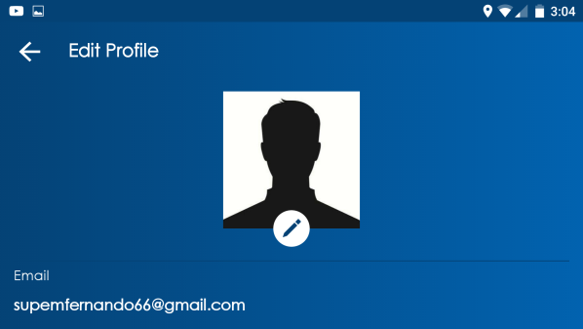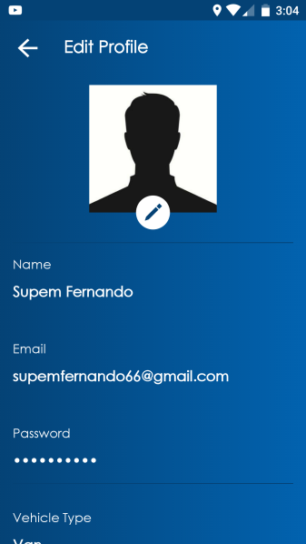Interfaces were designed to suit any type of display and any display rotation.

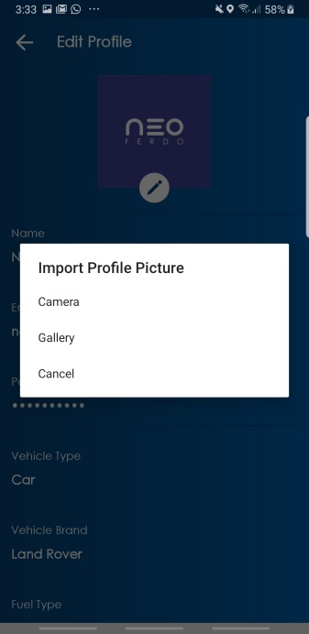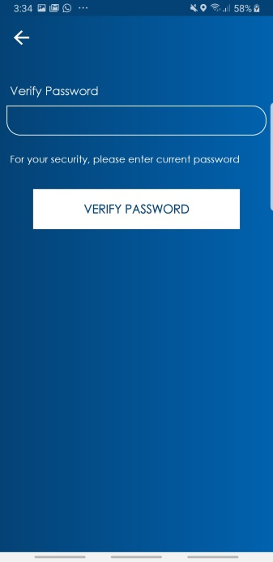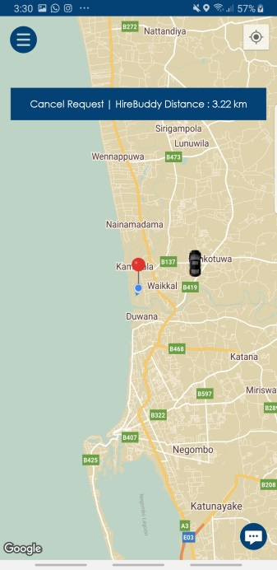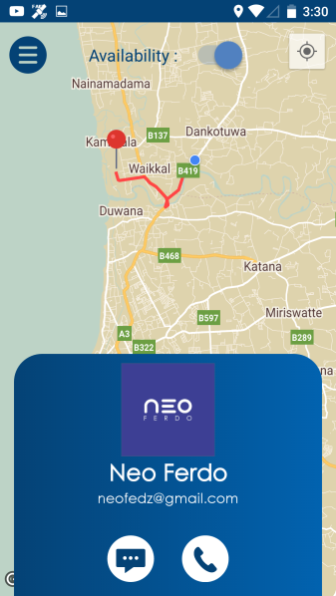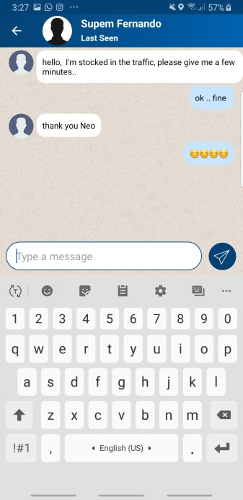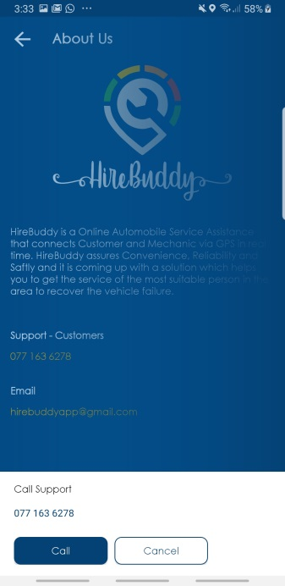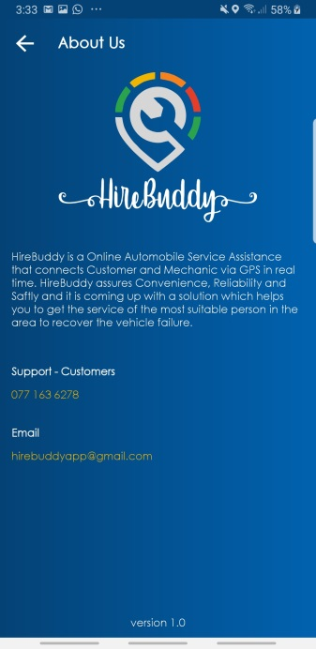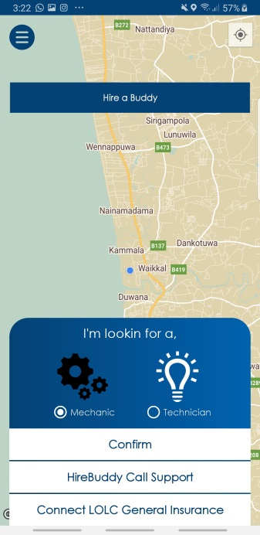Likewise, all the interfaces of the HireBuddy application were designed according to the user-friendly approach.